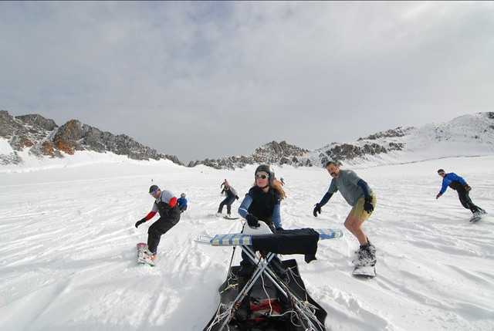Hi, Welcome to Extreme Ironing!!!

Extreme Ironing is an intense sport where daring individuals test their ironing skills in extreme conditions.

We combine the excitement of outdoor adventure with the pleasure that comes from a well pressed shirt.

Extreme Ironing requires an iron, ironing board and a few laundries to bring with you as you partake in this sport to places such as a mountain side, underwater or even while skiing. We suggest that you start of in your back yard before going more extreme, like mountainsides, woods or public places.